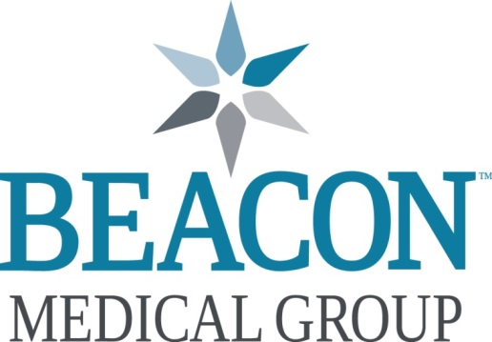

Adult Hospitalist

MISSION: We deliver outstanding care, inspire health, and connect with heart.
VALUES: Trust / Respect / Integrity / Compassion

Want to work in an environment with great teamwork and a high focus on quality? A transformational, once-in-a-generation capital construction project designed to enrich the patient, family, and provider experience is nearing completion at Beacon’s Memorial Hospital of South Bend campus. This $232 million, 300,000 square-foot, 10-story construction project will expand the number of beds at this location from 249 to 302. It is the largest construction project in Memorial’s 130-year history and is creating significant opportunity for immediate growth in the hospitalist program.

Beacon Medical Group is seeking full and part-time BC/BE Adult Hospitalists to add to our growing and expanding service. Beacon currently employs over thirty-four adult hospitalists and four advance practice providers at the Memorial Hospital South Bend (a level II Trauma Center) and Granger Hospital locations. Beacon’s hospitalists work predictable hours and have support with 24-hour ICU coverage, procedural support from top performing Interventional Radiology colleagues, no CODE BLUE, RAT Call or CODE Stroke responsibility. The practice treats patients with a wide range of socio-economic backgrounds and interesting pathology. Hospitalists cooperate in the care of varied medical issues across many specialties, including surgery, ICU and trauma. A full-time position includes approximately 183 shifts per year, some nights and some days. These shifts are 9 or 10 hours, not the typical 12-hour shifts seen in other organizations. Also unique are separate call and rounding shifts allowing for focused, uninterrupted patient rounding.

The hospitalist service is well respected in the community and providers receive great support from the specialists with whom they work. High-patient satisfaction scores combined with low-turnover rates demonstrate the strength and stability of the hospitalist program. The unique scheduling system allows providers to create important work-life balance, while group congeniality within the program generates a positive work atmosphere.

Affiliation with Indiana University School of Medicine in South Bend and Memorial Hospital Family Medicine Residency allows for teaching of residents, medical students and supervision of post-graduate trainees. Teaching opportunities and affiliated faculty appointments are available if interested yet not required.

Memorial Hospital has been honored numerous times for its quality patient care. Highlights include: Level II Trauma Center ▪ Dedicated Adult Critical Care, Neonatal, Maternal and Pediatric ▪ Transport Teams ▪ Memorial MedFlight ▪ Advanced Certification as a Thrombectomy-Capable Stroke Center: First and only in Indiana ▪ Memorial Regional Breast Care Center ▪ Memorial Hospital Surgery Center ▪ DaVinci Robotic Surgery ▪ Hybrid Operating Suites ▪ Memorial Regional Cancer Center ▪ Blue Distinction Center + Maternity Care Program • Designated Baby-Friendly Birth Facility ▪ Primary Stroke Center

Beacon offers a market competitive salary and benefits package, including a group compensation plan with productivity incentives, participation in available internal gains sharing program, additional shift pay, and other benefits such as: Medical, Dental, and Vision Insurance • Life Insurance • Short/Long-term Disability • CME Allowance • 403(b) and 457(b) Retirement Savings Plans • Paid Malpractice with Tail Coverage • and if applicable: Relocation Allowance • Student Loan Repayment Assistance

Beacon Health System locations span across north central Indiana and southwest Michigan. We are one of the top 2% of hospitals nationwide to achieve a 5 Star CMS Hospital Rating and an AA- bond rating, placing Beacon in the top 10th percentile of health systems across the country. Our physicians and associates enjoy direct access to excellent private and public (Blue Ribbon) schools, shopping and religious institutions that reflect the needs of our diverse communities, vibrant surrounding neighborhoods which include amenities such as the world-renowned University of Notre Dame and many options for athletic and cultural events. A “big little town,” South Bend is also home to the South Bend Cubs, a Class-A minor league baseball team. Parks, Potawatomi Zoo and numerous festivals offer family-friendly fun. Nearby, the sandy shores of Lake Michigan beckon with opportunities for camping, hiking or just relaxing. South Bend International airport is an easy, accessible airport with daily direct flights to many cities. And, Chicago is just 90 minutes away by car or rail so options for weekend getaways are endless.

For more information, or to submit your CV, please contact:
Caren Foster, Director Physician Recruiting
• Office: 574-647-1647 • Cell: 318-465-6445 • Email: cjfoster@beaconhealthsystem.org

