Policy /Procedure Document
Category/Source: | 02.0 Administrative
Origination Date: | 04/27/2000
Last Review Date: | 5/2/2022
Last Revised Date: | 5/2/2022
Next Review Due: | 12/15/2025
Policy Owner: | Vice President Medical Affairs
Required Approvals: | Medical Executive Committee
 | Hospital Leadership Committee

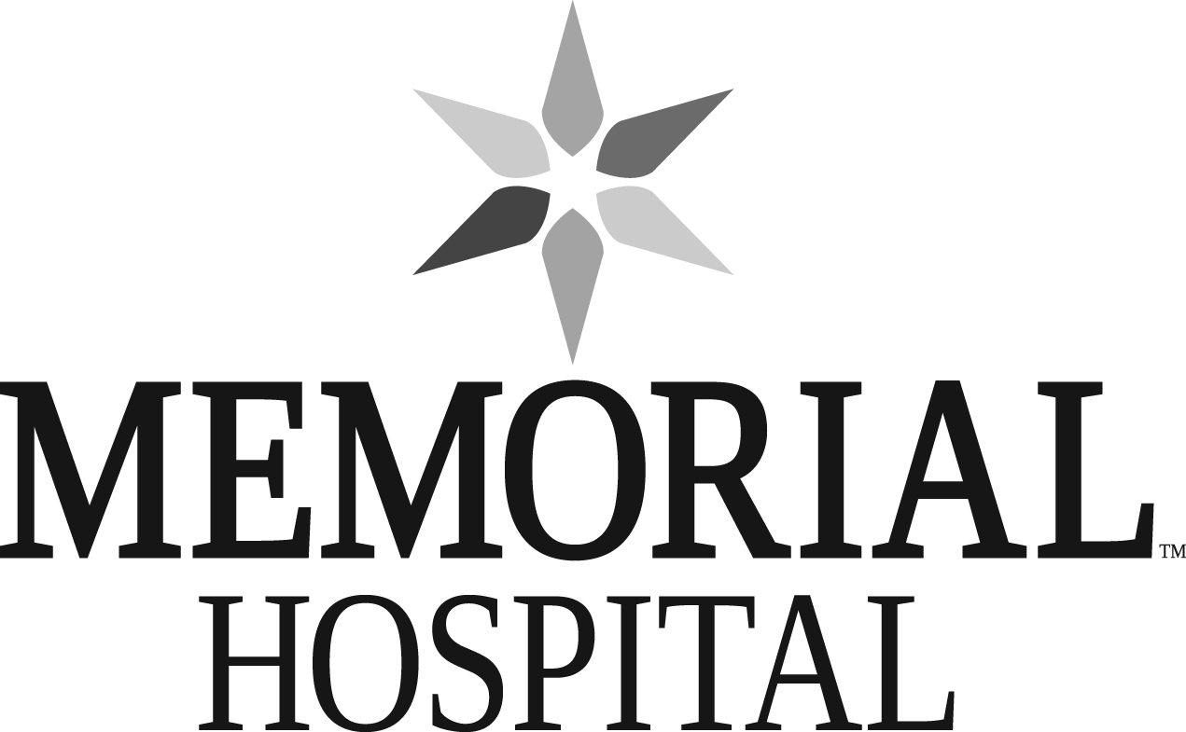

TITLE: | Professional Conduct Policy
SCOPE: | Memorial Hospital, Providers
PURPOSE: | It is the policy of Memorial Hospital ("Hospital") that all persons in the Hospital be treated with courtesy, respect, and dignity. To this end, the Hospital Board of Directors ("Board") and the Medical Staff require that all physicians, non-physician Providers, and all other health care staff and team members (collectively “Providers”) conduct themselves in a professional and cooperative manner in the Hospital. This policy is intended to provide a general framework for addressing instances of unprofessional conduct, or potential unprofessional conduct, by a Provider. Nothing in this policy is intended to negate or contradict any remedy or procedure set forth in the Medical Staff Bylaws (“Bylaws”), nor is this policy intended to prevent immediate referral of an incident to the Medical Executive Committee or Board as may be deemed necessary.
POLICY/PROCEDURE:

Guidelines:

- For purposes of this policy, examples of "Disruptive Conduct" include, but are not limited to:

- Threatening, abusive, or unprofessional actions or language directed at any Hospital patient, visitor, employee, personnel, team member, Medical Staff member, or any other individual at the Hospital (e.g., belittling, bullying, berating, and/or threatening any another individual);

- Degrading, demeaning, or disrespectful comments regarding any Hospital patient, visitor, employee, personnel, team member, Medical Staff member, or any other individual at the Hospital;

- Profanity or similarly offensive language while in the Hospital and/or while speaking with (or in the presence of) any Hospital patient, visitor, employee, personnel, team member, Medical Staff member, or any other individual at the Hospital;

- Public derogatory comments about the quality of care being provided by another Provider or the Hospital;

- Inappropriate medical record entries concerning the quality of care being provided by another Provider or the Hospital;

- "Sexual harassment," which for purposes of this particular Policy, is defined as unwelcome sexual advances, requests for sexual favors, or verbal or physical activity through which submission to advances is made an explicit or implicit condition of employment or future employment-related decision;

- Any unwelcome behavior or conduct which has the purpose or effect of unreasonably interfering with another Provider’s or Hospital employee’s work performance, or which creates (or risks creating) an offensive, intimidating or otherwise hostile work environment;

- Refusal to work cooperatively with another Provider or Hospital employee;

- Unreasonable failure to report Inappropriate Conduct;

- Unreasonable refusal to accept Medical Staff assignments or participation in committee or departmental affairs;

- Acts or omissions that adversely impact, or have the potential to adversely impact, the efficient operation of the Hospital; and

- Acts or omissions, whether at the Hospital or at another location, that are inconsistent with the level of professional conduct required by the Medical Staff Bylaws and/or that have the potential to damage or adversely affect the reputation of the Hospital.

- Inappropriate Conduct, unless accompanied by one of the behaviors outlined above, does not include:

- Identifying and attempting to appropriately resolve demonstrable quality concerns or related issues through designated Hospital grievance process and/or peer review processes.

- Reports or other expressions of patient care concerns, Provider quality concerns, or Hospital quality concerns through appropriate Hospital grievance and/or peer review processes;

- Other expressions of dissatisfaction through civil means of communication;

- Constructive criticism that is communicated in a respectful and responsible manner; and

- Other unique or “odd” personality traits or behaviors that do not constitute Unprofessional Conduct.

- Any instance(s) of Inappropriate Conduct shall be grounds for immediate review, investigation, and/or action as set forth below.

- Nothing in this policy, however, precludes immediate referral to the Medical Staff Medical Executive Committee (“MEC”) or the Board, or the elimination of any particular step in this policy, in dealing with a complaint about Inappropriate Conduct. Similarly, nothing in this policy precludes a suspension, restriction of privileges, or other action in accordance with the Medical Staff Bylaws or related Manuals.

Documentation of Disruptive Behavior:

- Documentation of Inappropriate Conduct is important – both to accurately record relevant events and also to effectively address the behavior. Consistent documentation is also helpful in identifying concerning patterns of Inappropriate Conduct. Providers and other Hospital employees who observe Inappropriate Conduct are expected to document the event and appropriately report the matter.

- Whenever reasonably possible, documentation of Inappropriate Conduct should include:

- The date and time of the conduct;

- A factual description of the conduct and related circumstances;

- The identify of any witnesses to the conduct, including but not limited to any patient(s) who may have observed the conduct and/or who may have been impacted (and any related patient records);

- Any known consequences of the behavior in relation to patient care, other individuals, or hospital operations; and

- Any action taken including date, time, place, action, and name(s) of those intervening.

- Documentation should be submitted to the Medical Staff Medical Executive Committee (“MEC”) by way of the applicable Department Chief, Medical Staff President, and/or Vice President of Medical Staff Affairs (“VPMA”) (or their respective, authorized designees) using the Hospital’s designated event reporting system. Any questions regarding the appropriate procedure or process to report such documentation or concerns should be directed to the Medical Staff Office, VPMA, or the individual’s immediate supervisor, director, or manager at the Hospital. The MEC representative may use judgement in determining need for escalation to reporting structure.

Guidelines for Addressing Inappropriate Conduct:

- The Department Chief or Medical Staff President or their designee and the Vice President of Medical Affairs (“VPMA”) or their designee (collectively "MEC Representative”), on behalf of and with the authority of the MEC, shall review the report and may (but is not required to) meet with the individual(s) who prepared the report and any other individuals reasonably deemed necessary, including the Provider subject of the report, in order to determine if the report of Inappropriate Conduct appears to be credible.

- In those instances when the report is determined to be credible, the MEC Representative shall either: (1) refer the matter directly to the MEC for further review and potential corrective action pursuant to the Medical Staff Bylaws, or (2) meet with the Provider (either as part of the meeting conducted pursuant to the preceding Paragraph A) or by way of a separate meeting.

- The following list serves as general guidance in evaluating specific cases of Inappropriate Conduct:

- Inappropriate Conduct is never acceptable; there is no legitimate excuse for this type of conduct.

- Initial reported incidents of Inappropriate Conduct will often be appropriate for a meeting with the Provider (as further addressed below), as opposed to direct referral to the MEC.

- However, a single egregious incident of Inappropriate Conduct can be grounds for immediate referral to the MEC for potential investigation, Summary Action, and/or Corrective Action.

- Similarly, multiple reported incidents (whether reported individually or reported as a series of "smaller" incidents) can be just as problematic as a single, egregious incident, and should generally be reported to MEC for potential investigation, Summary Action, and/or Corrective Action.

- Consistent with the foregoing, previous incidents of Inappropriate Conduct (whether or not previously documented) may be considered when evaluating new instances of similar conduct.

- In the event the MEC Representative elects to meet with the Provider (as opposed to referring the matter directly to the MEC), the MEC Representative should: (1) provide a copy of this policy to the Provider, (2) educate the Provider regarding the potential adverse ramifications of Inappropriate Conduct, and (3) emphasize that Inappropriate Conduct will not be tolerated at the Hospital and that further instances of such behavior may be reported directly to the MEC.

- The MEC Representative should document this meeting and provide a copy of this documentation to MEC. Following the meeting with the Provider, the MEC Representative should additionally correspond with the Provider to reiterate the expectation for appropriate behavior moving forward. The meeting documentation and a copy of the correspondence to the Provider should be placed in the Provider’s confidential Medical Staff file.

- All review, communications, and other actions taken pursuant to this policy shall be treated as a confidential peer review activities.

 |  | Document Revision History:
Review Date: | Revised Date: |  | Reviewed/Revised By: | Summary of Changes:
04/27/2000 |  |  | Becky Starzynski | Original Document
 | 08/08/2002 |  | Becky Starzynski | Replaces Last Policy
 | 08/08/2006 |  | Becky Starzynski | Review/Revised
08/25/2008 |  |  | Becky Starzynski | Reviewed and Updated to New Format
04/13/2009 |  |  | Becky Starzynski | Reviewed and Updated to New Format
08/06/2012 |  |  | Becky Starzynski | Reviewed
11/24/2015 |  |  | Becky Starzynski | Reviewed and Updated to New Format
12/15/2017 | 12/15/2017 |  | Cheryl Wibbens, MD | Changes: References of CEO to Hospital President, policy ownership from Risk Manager to VPMA, required approvals to MEC/HLC
 | 04/2022 |  | Chris Eades | Revised by Hospital Attorney
05/02/2022 |  |  | MEC | Approved

SIGNATURES OF APPROVAL:

Date Signed | Signature | Name | Title
_________ | ________________________
_________ | ________________________

